PROJECT DOCUMENT

* **Project Title**: A CRM Application For Banquet Hall Booking
* College Name: Annamacharya Institute of Technology and Science

**TEAM**

* + **Team ID:** LTVIP2025TMID29022
  + **Team Size:** 4
  + **Team Leader:** Maddileti Bhavitha
  + **Team member:** Lakshmi Likhita A
  + **Team member:** Y Kanakavathi
  + **Team member:** Shruthi Dnyanoba Sadewad

**MAIL IDs:**

maddiletibhavitha2003@gmail.com

lakshmilikhithaavisetti@gmail.com

kanaka.dce@gmail.com

sadewadshruthi@gmail.com

**Project Overview:** A CRM Application For Banquet Hall Booking

* Objective :

This project is to develop a comprehensive booking management system for a banquet hall business using Salesforce. The system will streamline the booking process, manage event details, and provide insights into sales and revenue. Additionally, it will include features to manage catering/menu selection, DJ services, decorations, themes related to weddings, and other marriage-related services. Implement flow to ensure data integrity and prevent double bookings.

**IDEATION PHASE**

The Ideation Phase serves as the foundation of any successful project. It blends creativity, user empathy, and structured thinking to identify the core challenges, generate meaningful ideas, and prioritize solutions that bring tangible value to all users involved. This dynamic phase combines imagination with insight to ensure every feature addresses real-world needs.

As our project titled: **“A CRM Application for Banquet Hall Booking,”** the ideation process was essential to tailor the system to the specific needs of venue managers, event organizers, service vendors, and customers. By deeply understanding their workflows and challenges, we focused on creating a solution that streamlines bookings, improves client communication, and enhances overall event planning efficiency

1. **Brainstorming & Idea Prioritization Template**

**Step 1: Team Gathering, Collaboration, and Selecting the**

**Problem Statement**

Our team convened with the goal of identifying inefficiencies in the current banquet hall booking process and proposing a tech-enabled solution using Salesforce. Through collaborative brainstorming sessions, digital whiteboards, and real-world scenario mapping, we collectively analyzed the operational challenges faced by banquet hall managers, event organizers, and support staff. We examined existing workflows and discovered that most banquet halls still rely on fragmented and manual systems for managing:  
● Booking and scheduling of halls  
● Customer communications and inquiries  
● Payment tracking and invoice generation  
● Event coordination and vendor assignment

After several discussions and stakeholder reviews, we clearly articulated the core issue:  
**Problem Statement:**  
“Banquet hall operators lack a centralized digital platform to manage bookings, customer data, payments, and vendor coordination in real time. The current manual processes are inefficient, prone to conflicts, and limit visibility into business performance.”

This statement became the cornerstone of our project scope and set the direction for developing a tailored, CRM-powered platform that would streamline operations and elevate the customer experience.

**Step 2: Brainstorm, Idea Listing, and Grouping**

We conducted a collaborative brainstorming session using a digital whiteboard where each team member contributed raw ideas based on industry research and user needs. The ideas were then reviewed and grouped into major themes:

* **Booking & Scheduling**: centralized calendar for multiple halls, real-time conflict detection
* **Customer Relationship Management**: client profiles, preferences, event history
* **Communication & Notifications**: automated email/SMS/WhatsApp reminders and confirmations
* **Analytics & Reporting**: dashboards showing revenue trends, hall utilization, peak booking seasons
* **Access Control & Security**: role-based permissions for managers, vendors, and staff

From a pool of 25–30 ideas, we clustered and shortlisted those that directly improved efficiency, reduced manual work, and elevated the customer experience. These formed the foundation for our product roadmap.

**Step 3: Idea Prioritization**

Each clustered idea was carefully evaluated against three key criteria:

* **Feasibility** – Ease of implementation using Salesforce’s capabilities
* **Impact** – How significantly the feature would improve venue operations
* **Urgency** – Whether the idea addressed an immediate operational or user-facing challenge

To narrow down the MVP (Minimum Viable Product) scope, we used a decision matrix that helped surface the highest-value features.

* **Top Priority Features:**  
  ○ Real-time booking calendar with conflict prevention  
  ○ Customer profile management and event history tracking  
  ○ Automated reminders and confirmations (via SMS/Email/WhatsApp)  
  ○ Interactive dashboards showing hall utilization, revenue, and peak demand times  
  ○ Secure, role-based access for admins, coordinators, and vendors

These features were prioritized for their direct impact on streamlining operations

**2. Empathy Mapping- Empathize & Discover**

Empathy Map Canvas

An **empathy map** is a visual tool that helps teams develop a deeper understanding of users’ experiences, frustrations, and aspirations. We used this tool to map the daily journey of key banquet hall booking stakeholders—including **venue managers, event coordinators, vendors, and customers**—to surface the emotional and operational realities they face.

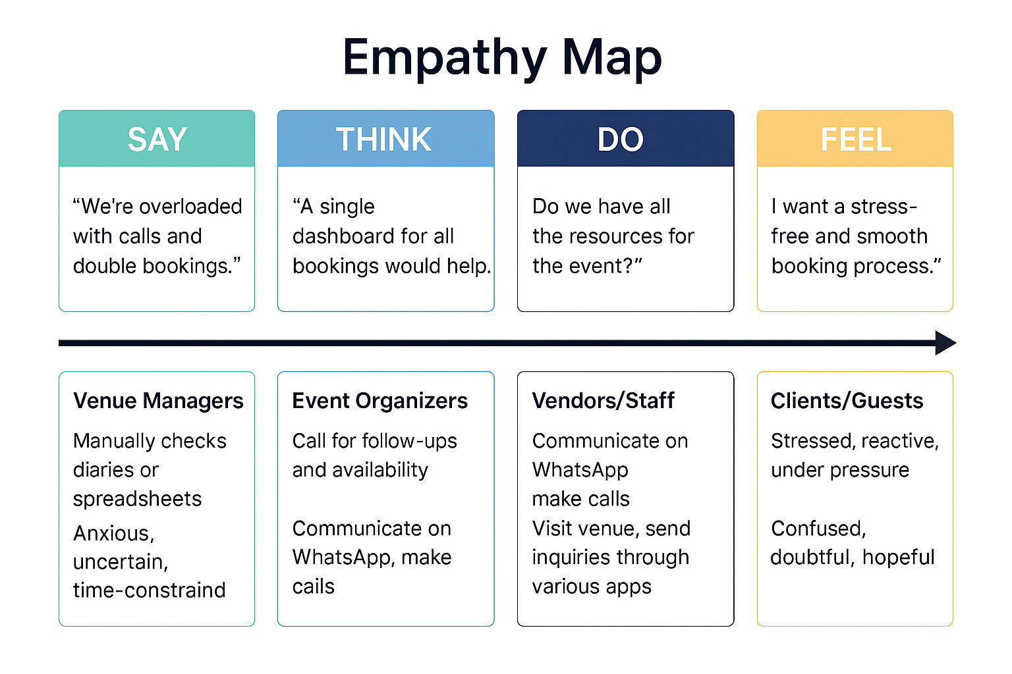

By stepping into the user’s shoes, we ensured that our Salesforce CRM features (formulas, flows, triggers, dashboards) directly addressed their key frustrations.

**3.Define the Problem Statements**

**Customer Problem Statement Template**

Banquet hall operators and event managers currently manage bookings, customer interactions, and vendor coordination through fragmented and often manual processes. This results in scheduling conflicts, missed follow-ups, payment tracking errors, and lack of visibility into overall business performance. A centralized Salesforce CRM system can streamline booking workflows, manage customer data efficiently, automate communications, and provide real-time insights through dashboards, flows, and automation. This statement reflects the expectations of venue managers and clients and served as a guiding reference for our object models, data validations, process automations, and reporting configurations.

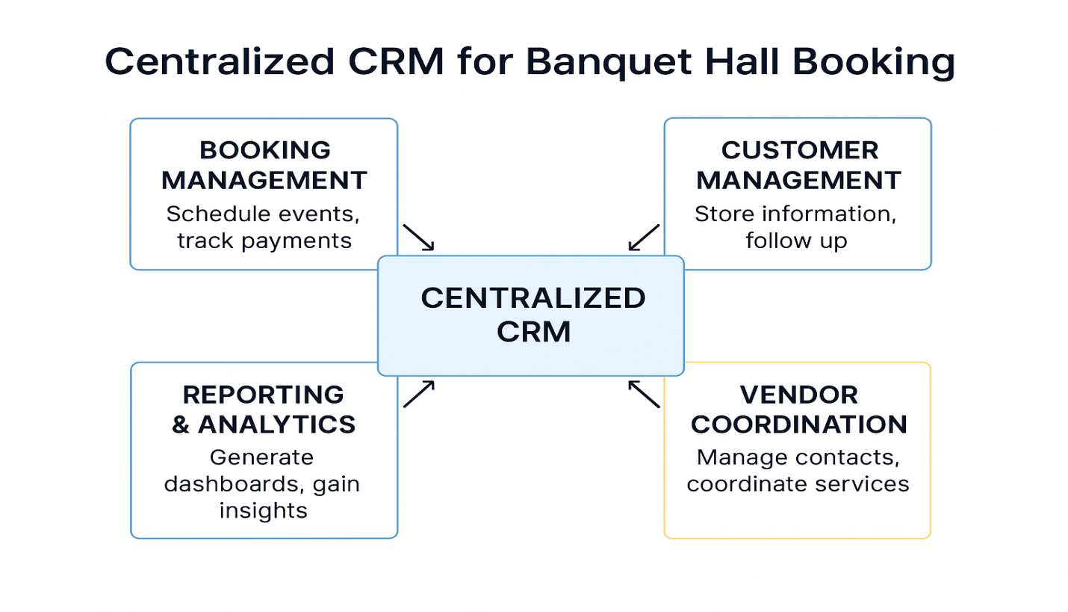

**REQUIREMENT ANALYSIS**

The **Requirement Analysis Phase** focuses on gathering, structuring, and validating all essential system needs to ensure a clear roadmap for development. It ensures that the solution is not only technically robust but also directly aligned with what key stakeholders—such as banquet hall managers, event coordinators, vendors, and clients—actually require.

In our project, **“A CRM Application for Banquet Hall Booking,”** this phase acted as the bridge between identifying booking-related challenges and shaping an intelligent system design. Through detailed user journeys, workflow analysis, and functional requirement gathering, we outlined critical needs such as real-time scheduling, customer data handling, vendor assignment, and seamless communication.

**1.Customer Journey Map-Understanding User Experience Flow**

**Purpose:** The **Customer Journey Map** visualizes how key stakeholders in the banquet hall ecosystem—such as **Venue Managers, Event Coordinators, Clients, and Service Vendors**—interact with the booking and event management process on a daily basis. It highlights core actions, common pain points, emotional highs and lows, and potential areas of improvement. This real-world perspective informs the CRM design to ensure it aligns seamlessly with user behaviors, eliminates manual inefficiencies, and enhances the overall event planning experience.

**Journey steps:**

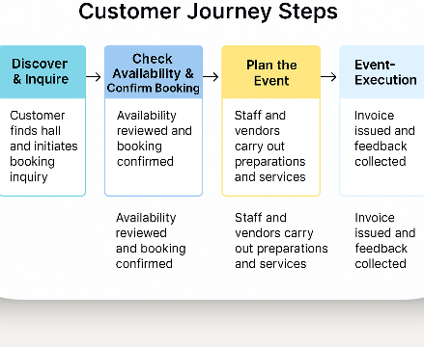

**2.Data Flow Diagram:**

**Purpose:** Mapping Information Flow Between Objects

The **Data Flow Diagram (DFD)** models how information moves between Salesforce objects and components in the banquet hall CRM system. It helped us structure relationships between:

* **Customer**, **Booking**, **Venue**, **Event Details**, **Vendor**, and **Payment**

**Level 1 DFD Overview**

**1. Admin & Staff Inputs:**

* Create and update **Customer** profiles
* Add **Venue availability**, **Booking details**, and **Event requirements**
* Assign **Vendors** for catering, decoration, etc.

**2. System Logic:**

* Validates booking slots and venue availability
* Fetches vendor services and costs via flows based on event type and scale
* Calculates total charges using formula (Service Costs + Venue Fees + Discounts)

**3. Outputs:**

* Generates performance dashboards (e.g., revenue by event type, vendor utilization)
* Sends automated booking confirmations and payment receipts
* Triggers error messages for time conflicts or missing vendor assignments

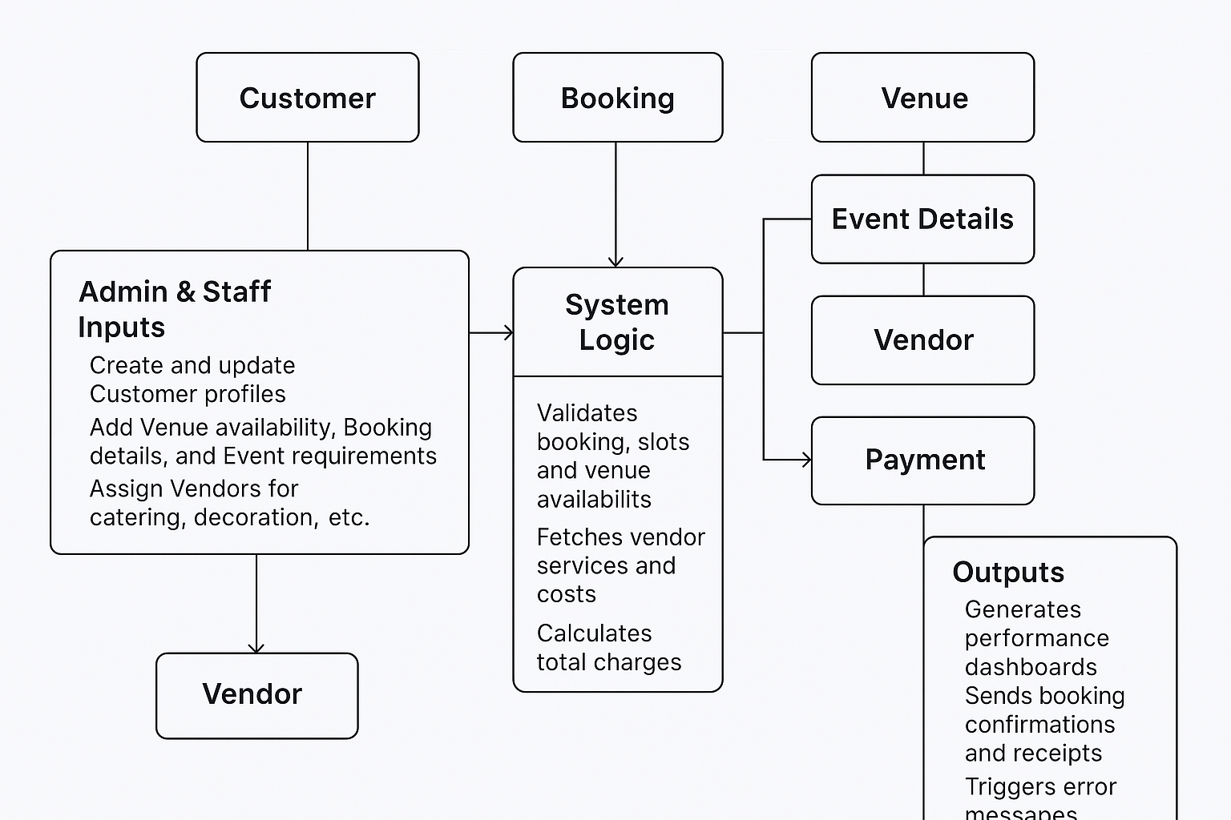

**3. Solution Requirements:**

What the CRM System Must Do

**Functional Requirements:**

* **Create custom objects for**:
  + **Venue** (with capacity, location, availability)
  + **Booking** (with date, time, customer, event type)
  + **Customer** (contact info, history, preferences)
  + **Vendor** (services, costs, availability)
  + **Payment** (methods, totals, transaction status)
* **Establish relationships** using **lookup**, **master-detail**, and **formula fields**:
  + Booking → Customer, Venue, Vendor
  + Payment → Booking
  + Dynamic pricing logic via formulas (e.g., duration × rate)
* **Validate booking logic** using **Apex Triggers**:
  + Prevent double bookings
  + Ensure vendors aren't double-assigned
  + Trigger alerts if hall capacity is exceeded
* **Automate workflows using Flows**:
  + Auto-confirm availability
  + Trigger payment reminders and vendor notifications
  + Generate event checklist from booking details

• **Support analytics through**:

* Dashboards showing booking trends, revenue, vendor utilization
* Reports for customer feedback, booking frequency, peak seasons

**Non-Functional Requirements:**

* **Intuitive Lightning App Interface** for staff and managers
* **Real-time validation** for booking conflicts and data accuracy
* **Centralized and relational database** with clear object-linking for high usability, data consistency, and scalability

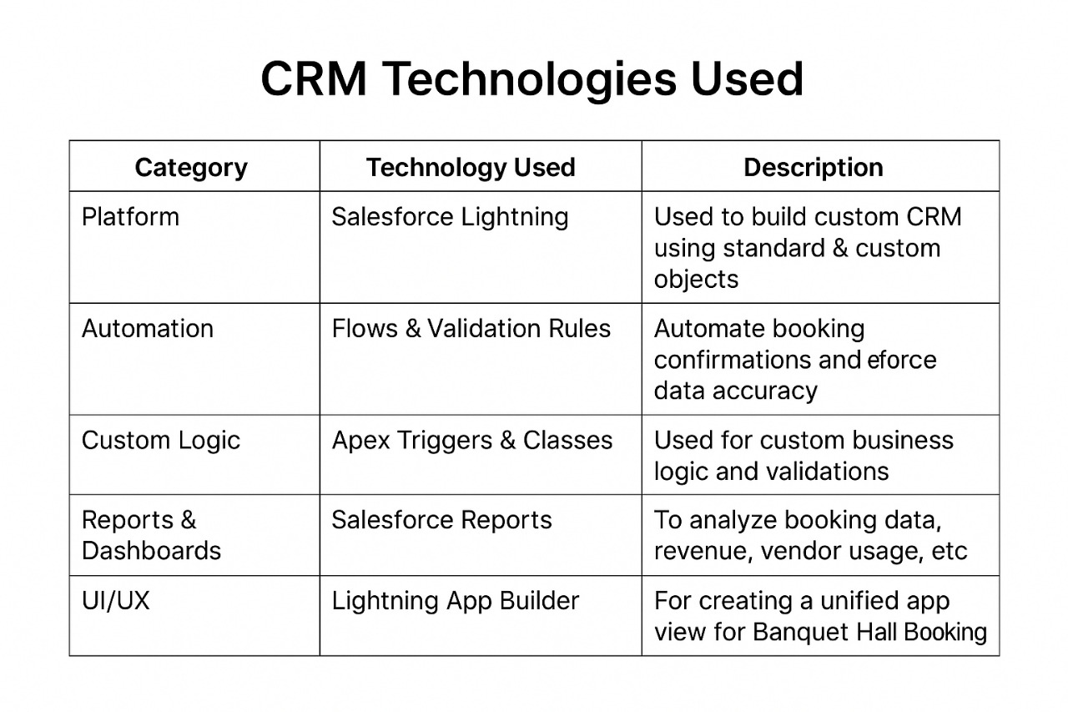**4. Technology Stack:**

**Summary:**

The Requirement Analysis Phase for the CRM Application for Banquet Hall Booking ensured that system features were rooted in real user pain points like miscommunication and booking clashes. It guided the creation of structured Salesforce objects, automated flows, and relationship logic. This phase shaped the app’s UI and dashboards, aligning technology with stakeholder needs. Overall, it laid the groundwork for a smart, efficient, and user-centered solution.

**Project Design Phase**

The Project Design Phase laid the technical and functional blueprint for the banquet hall CRM system, ensuring it addressed real user needs while remaining scalable and aligned with Salesforce best practices. It transformed validated pain points into structured objects, flows, and business rules. This phase guided decisions around data relationships, automation logic, and UI components, bridging the gap between user insights and a buildable, maintainable solution.

**1. Problem–Solution Fit:**

**Problem Recap**:

* Current processes are manual or scattered across spreadsheets and calls, leading to inefficiencies
* Frequent data entry errors and duplicated customer or event information
* Lack of real-time visibility for managers into hall availability, staff assignments, or upcoming events
* Poor coordination in assigning vendors and staff, resulting in last-minute issues
* Challenges in tracking payments, generating post-event reports, and analyzing booking trends
* Banquet hall operations demand real-time coordination across bookings, venues, vendors, and payments

**Does the Proposed Solution Fit?**

Yes. The Salesforce CRM solution:

* Introduces object-level control for **Bookings, Venues, Customers, Vendors, and Payments**
* Enables automated **service pricing and availability checks** through Flows
* Validates **vendor assignments and booking conflicts** using Apex Triggers
* Summarizes operational performance using **Reports and Dashboards**
* Uses **formula fields** to dynamically calculate charges and event costs
* Creates **centralized scheduling and coordination views** using Lightning App Builder

Thus, it directly addresses the operational pain points of managing banquet hall bookings and event logistics in a unified, scalable, and efficient manner.

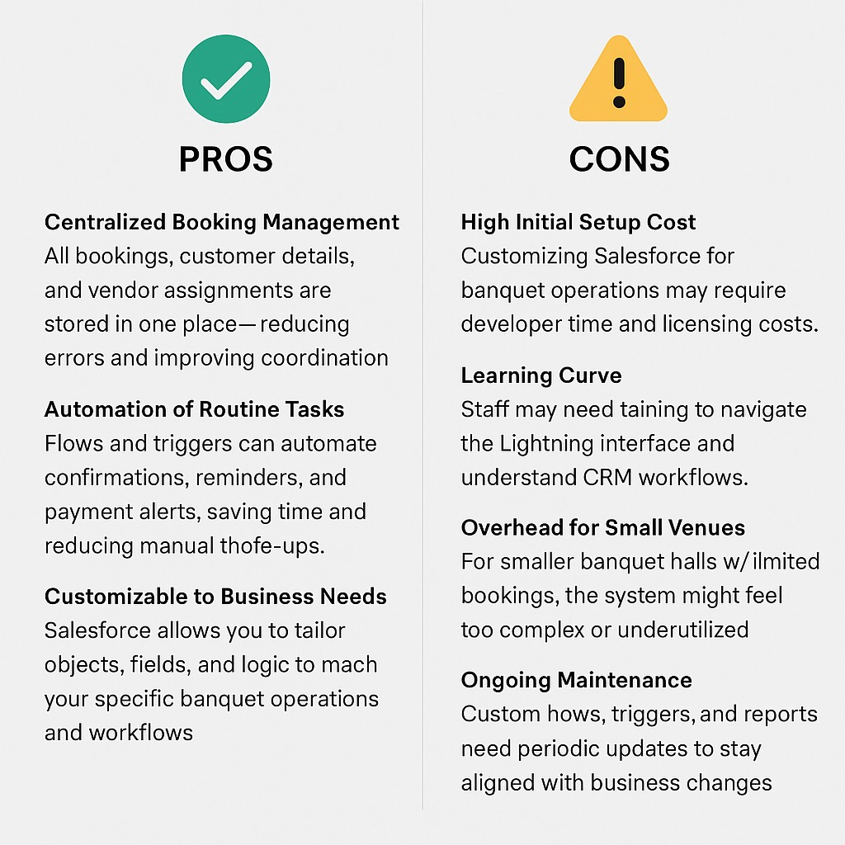

**2. Proposed Solution:**

Our proposed CRM application is designed to digitize and streamline banquet hall booking operations using Salesforce’s powerful customization capabilities.

**Key Functional Features:**

**● Custom Objects:**

* Venue, Booking, Customer, Vendor, Event Details, and Payment

**● Automation & Validation:**

* Vendor assignment checks (e.g. caterers, decorators) using Apex Triggers
* Total cost calculation automation using Flows based on services and duration
* Input validation for booking conflicts, missing information, or overbooking

**● Formula Fields for Efficiency:**

* Event Duration = End Time – Start Time
* Total Event Cost = Base Venue Fee + Vendor Charges – Discounts
* Auto-lookup of assigned Vendor Names and Customer Contact Info

**● UI & Navigation:**

* Banquet Booking App built using Lightning App Builder
* Tabs for each custom object and user-tailored page layouts for staff, managers, and vendors

**● Reports and Dashboards:**

* Booking Summary Reports by date, type, or customer
* Vendor Assignment Dashboards showing service load and availability
* Monthly Revenue and Event Frequency Tracking Dashboards

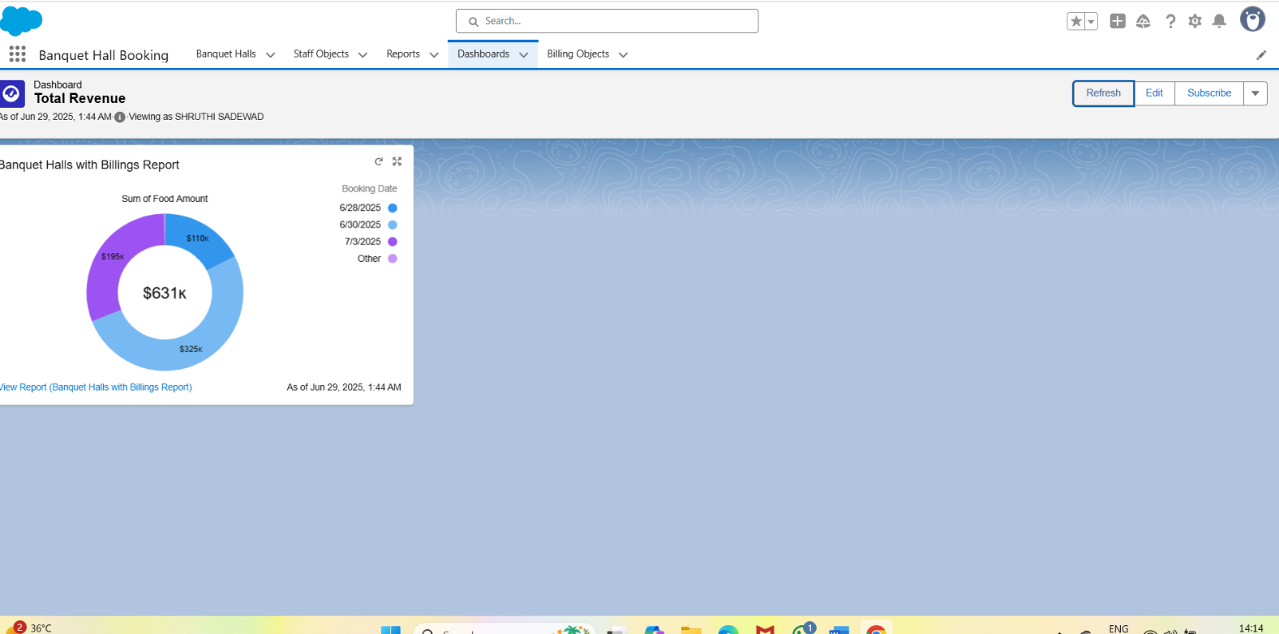

**3. Solution Architecture:**

**Object Relationship Overview**

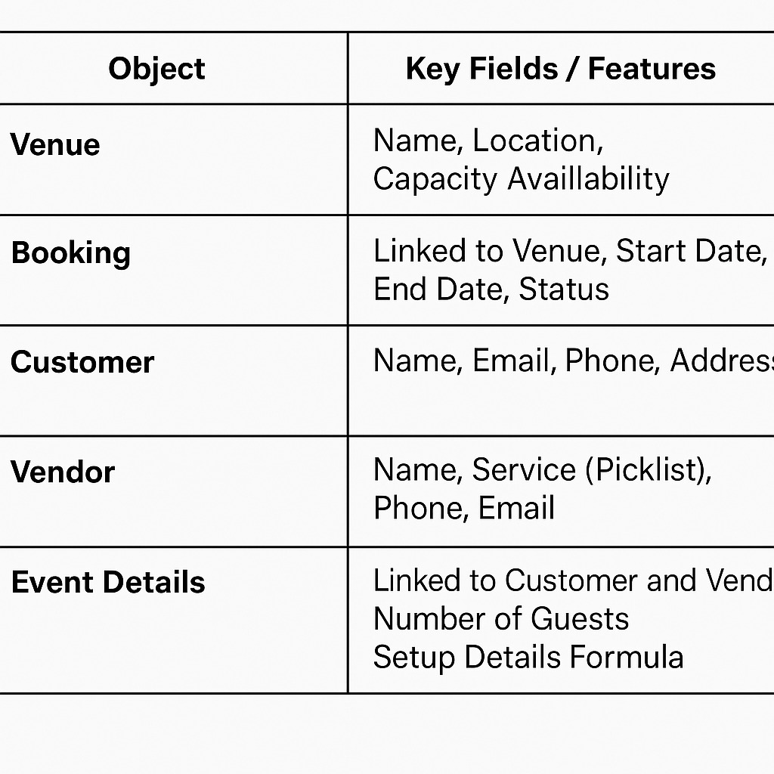

Lookups:

* Staff Member → Venue
* Booking → Venue, Customer, Event Coordinator, Vendor Package
* Vendor Package → Vendor

Formulas:

* IF( Customer_Name__r.Archestra__c = TRUE, 50000, 0)
* IF( Customer_Name__r.DJ__c = TRUE, 70000, 0)
* IF( Customer_Name__r.Magician__c , 15000, 0)
* IF( Customer_Name__r.Shenai_and_Mridangam__c = TRUE, 25000, 0)
* IF( Customer_Name__r.Kolatam__c , 15000, 0)
* CASE( Customer_Name__r.Food_Menu__c , 'Veg', 450,

'Special Veg', 550,

'Non-Veg', 550, 650)

* Food_Amount_per_Plate__c   *  Customer_Name__r.No_of_Visitors__c
* CASE( Customer_Name__r.Decoration_Purpose__c ,'Marriage', 50000,

'Reception', 60000,

'Anniversary', 30000,

'Birthday', 25000 ,

'Other Events', 20000 , 0)

* Booking_Date__c  <=  TODAY()

Automation:

* Flows for service pricing logic
* Triggers for vendor assignment validation
* Reports & dashboards for operational insights

**Summary:**

The Project Design Phase ensured that our banquet hall CRM solution aligned closely with the needs of customers, staff, and managers while adhering to Salesforce best practices in object modeling, validation, automation, and UI design. It provided a structured foundation for booking workflows, vendor coordination, and event cost logic. This comprehensive design blueprint served as a critical guide for the upcoming build and configuration stages, ensuring clarity and scalability.

**Project Planning Phase**

The Project Planning Phase transformed major project milestones into manageable, time-bound sprints aligned with the banquet hall CRM development timeline. This approach ensured clear task ownership, streamlined collaboration, and consistent progress tracking. By breaking down features like booking automation, vendor assignment, and reporting into structured deliverables, the team was able to execute efficiently and stay aligned with project goals and stakeholder expectations.

**Project Planning Template**

Sprint Schedule – Based on Project Milestones

|  |  |  |  |  |
| --- | --- | --- | --- | --- |
| **Sprint** | **Functional**  **Requirement**  **(Epic)** | **T ask (Mapped from**  **Milestone)** | **Priority** | **Team Members** |
| Sprint-1 | Developer  Setup & Basic  Objects | Creating Developer  Account & Activating  Org | High | Member 1 |
| Sprint-1 | Custom Object  Creation | Creating custom  Objects-A Banquet  booking application | High | Member 1,2 |
| Sprint-2 | UI Tabs & App  Creation | Creating Tabs &  Lightning App | High | Member 3 |
| Sprint-2 | Field  Configuration | Creating fields,  formula fields,  picklists, relationships | Medium | Member 1,3 |
| Sprint-3 | Layouts &  Validations | Page Layouts +  Validation Rules | High | Member 2,4 |
| Sprint-3 | Flows &  Triggers | Automations using  Flows and Apex  Triggers | High | Member 2,3 |
| Sprint-4 | Reports &  Dashboards | Generate Reports and  create Dashboards | High | Member 4 |
| Sprint-4 | Final  Integration &  Conclusion | Final Review, Testing,  and Functional  Summary | Medium | All Members |

Project Tracker & Sprint Timeline

Duration: Each sprint is 6 days, aligned with your June 2025 internship

Schedule.

|  |  |  |  |  |
| --- | --- | --- | --- | --- |
| **Sprint** | **Duration** | **Sprint start**  **date** | **Sprint end**  **date** | **Sprint release**  **date** |
| Sprint-1 | 6 Days | 03 Jun 2025 | 08 Jun 2025 | 08 Jun 2025 |
| Sprint-2 | 6 Days | 09 Jun 2025 | 14 Jun 2025 | 14 Jun 2025 |
| Sprint-3 | 6 Days | 15 Jun 2025 | 20 Jun 2025 | 20 Jun 2025 |
| Sprint-4 | 6 Days | 21 Jun 2025 | 26 Jun 2025 | 26 Jun 2025 |

**Summary:**

The Project Planning Phase allowed our team to convert 12 major

milestones into 4 streamlined sprints with assigned priorities and contributors.

By aligning sprints with real internship dates and breaking tasks down into

functional chunks, we ensured steady progress and simplified execution

**Project Executable Files**

This phase outlines the actual Salesforce configurations, data models, and outcomes implemented during the execution of the Banquet Hall Booking CRM application. It ensures that all key elements—custom objects, automation flows, validations, and reports—are clearly documented and aligned with real-world use cases. The components developed in this phase are designed to be traceable, reusable, and easily assessable for future improvements or audits. It captures the practical realization of booking flows, vendor assignment rules, and payment tracking modules, offering clarity, replication, and validation across the entire system lifecycle.

**6.1 Project Files**

**Project Executable Files**

The following project files were executed in the Salesforce Developer Org:

Milestone 1: Developer Account Setup

Milestone 2: Object Creation

Milestone 3: Tab Creation

Milestone 4: Lightning App Setup

Milestone 5: Field Creation

Milestone 6: Page Layouts

Milestone 7: Creation Of Record Types

Milestone 8: Validation Rules

Milestone 9: Flow Setup

Milestone 10: Apex Trigger

Milestone 11: Reports

Milestone 12: Dashboards

Milestone 13: Final Review

**List of Milestone Tasks with Supporting Screenshots and**

**Descriptions**

**Milestone 1: Developer Account Setup**

● Created and activated a Salesforce Developer Org.

● Link: <https://developer.salesforce.com/signup>

● Setup the base environment for CRM development.

● Verified access to Object Manager, Flow Builder, and App Builder

**OUTPUT SCREENSHOT**

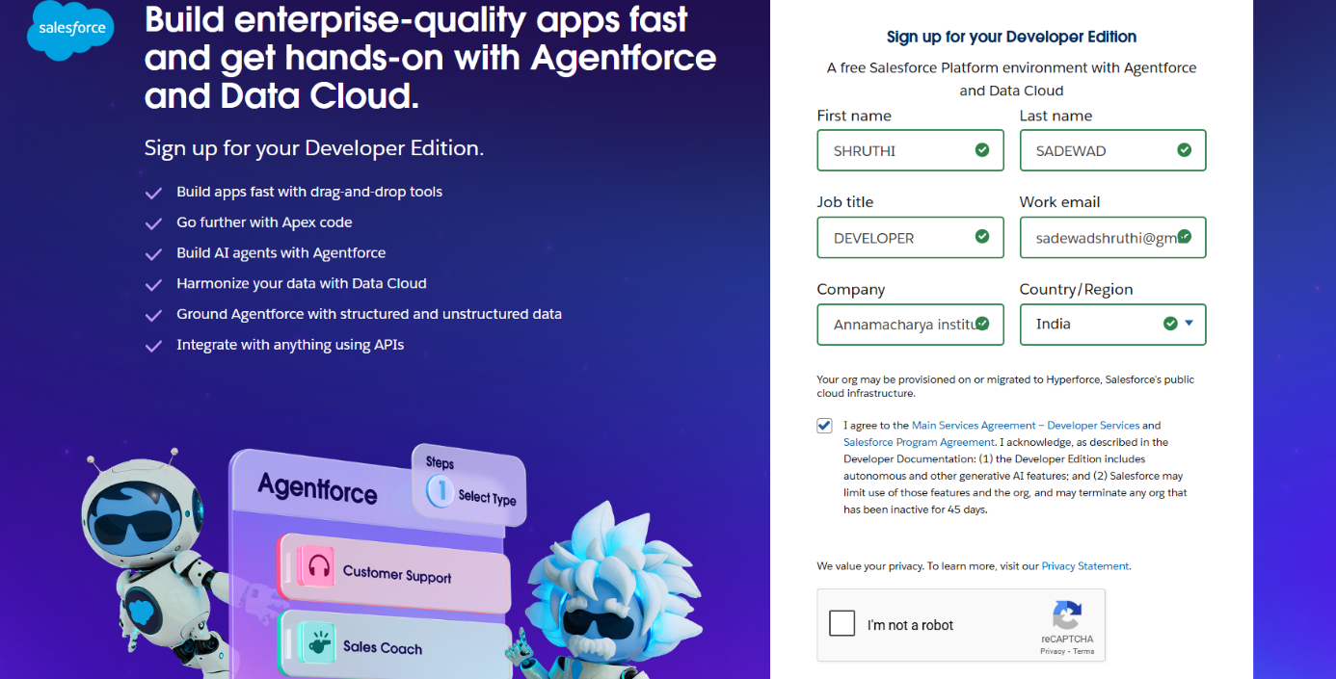

**Milestone 2: Object Creation**

● Created 3 custom objects:

○ Banquet hall custom, Billing and Staff

● Established foundational schema for Banquet Hall Booking.

● Configured relationships using lookup fields.

**OUTPUT SCREENSHOT**

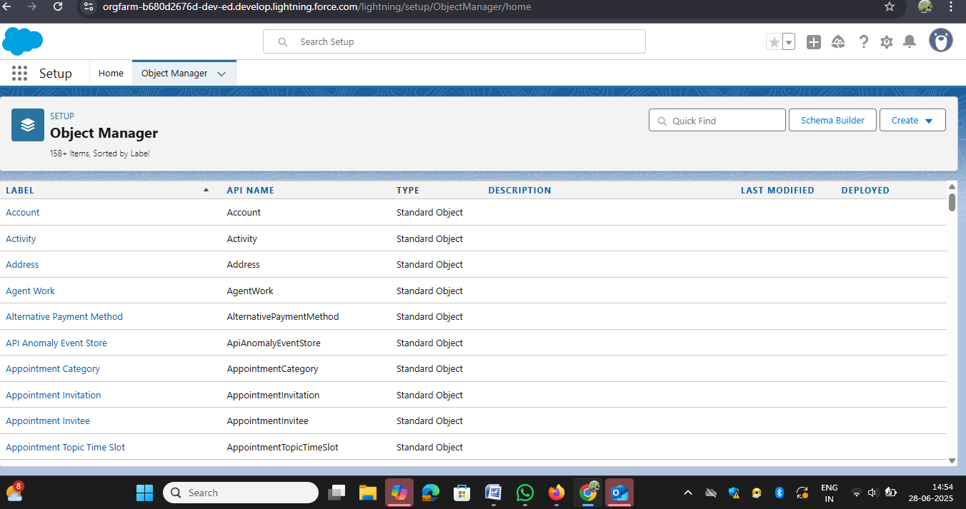

**Milestone 3: Tab Creation**

**●** Created tabs for each custom object.

● Enabled easy navigation and object access in the app.

● Ensured users can create/view records from the UI.

**OUTPUT SCREENSHOT**

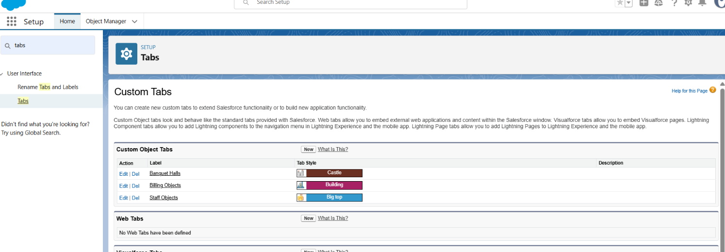

**Milestone 4: Lightning App Setup**

● Built a custom Lightning App named " Banquet Hall Booking".

● Added relevant tabs to centralize operations.

● Simplified user workflow by grouping features.

**OUTPUT SCREENSHOT**

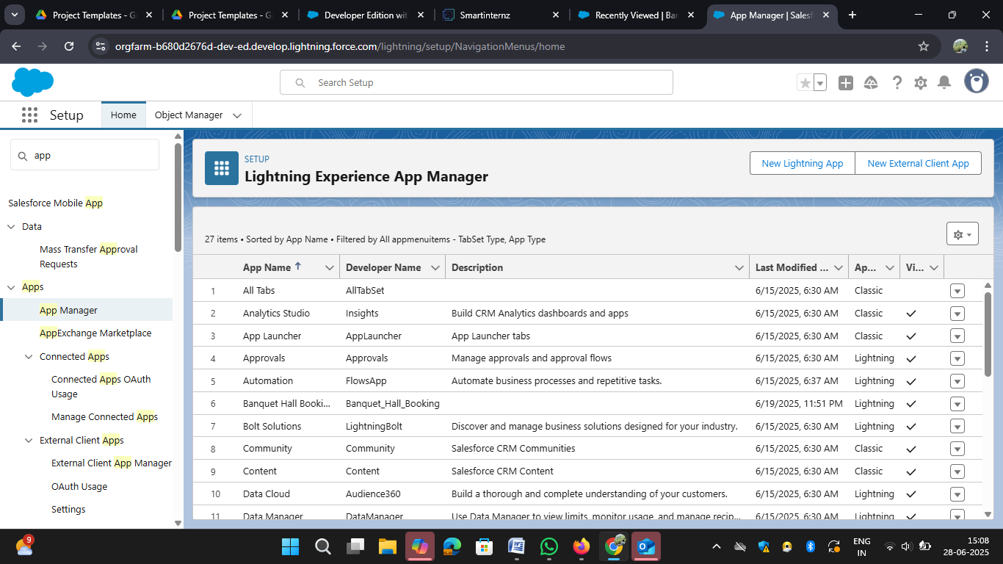

**Milestone 5: Field Creation**

● Added custom and formula fields like:

* Banquet Hall, Staff, Billing

Formula:

* IF( Customer_Name__r.Archestra__c = TRUE, 50000, 0)
* IF( Customer_Name__r.DJ__c = TRUE, 70000, 0)
* IF( Customer_Name__r.Magician__c , 15000, 0)
* IF( Customer_Name__r.Shenai_and_Mridangam__c = TRUE, 25000, 0)
* IF( Customer_Name__r.Kolatam__c , 15000, 0)

**OUTPUT SCREENSHOT**

**Banquet Hall Object Fields**

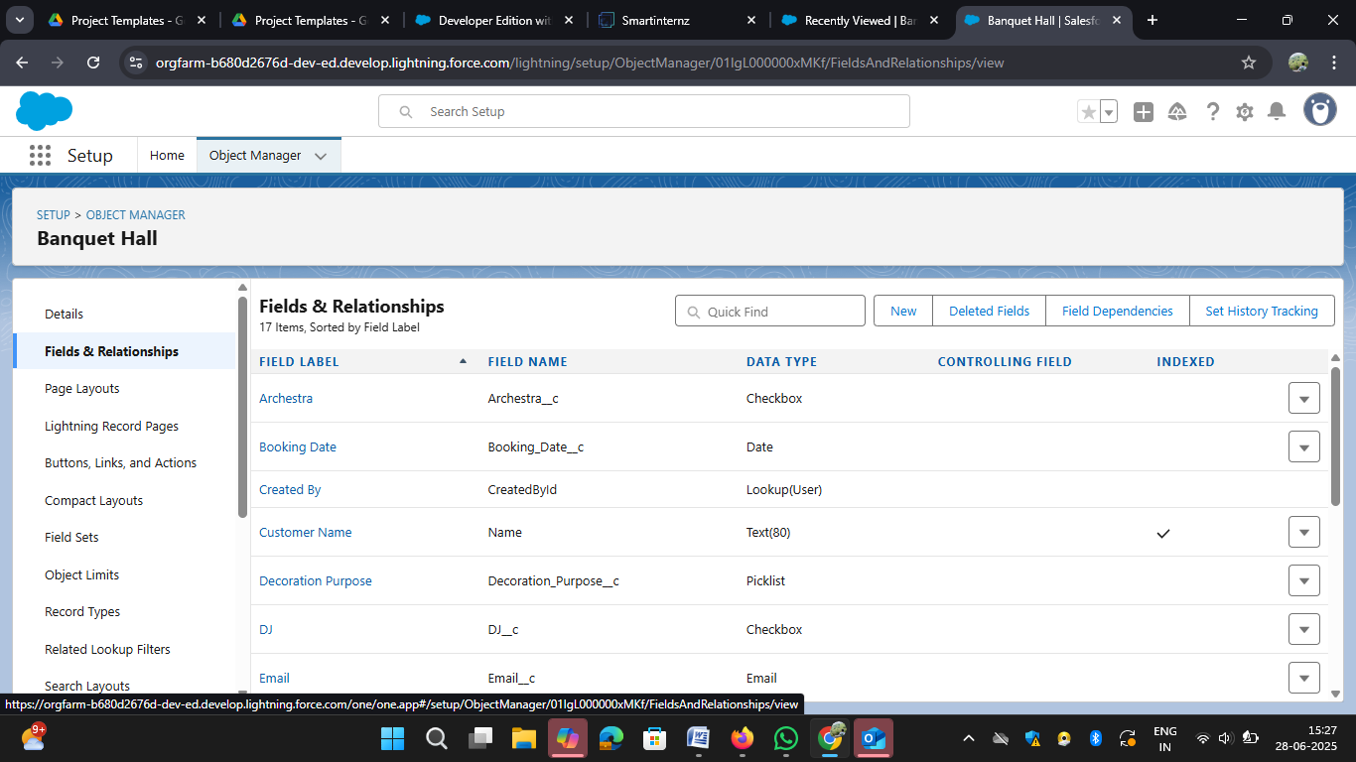

**Staff Object Fields**

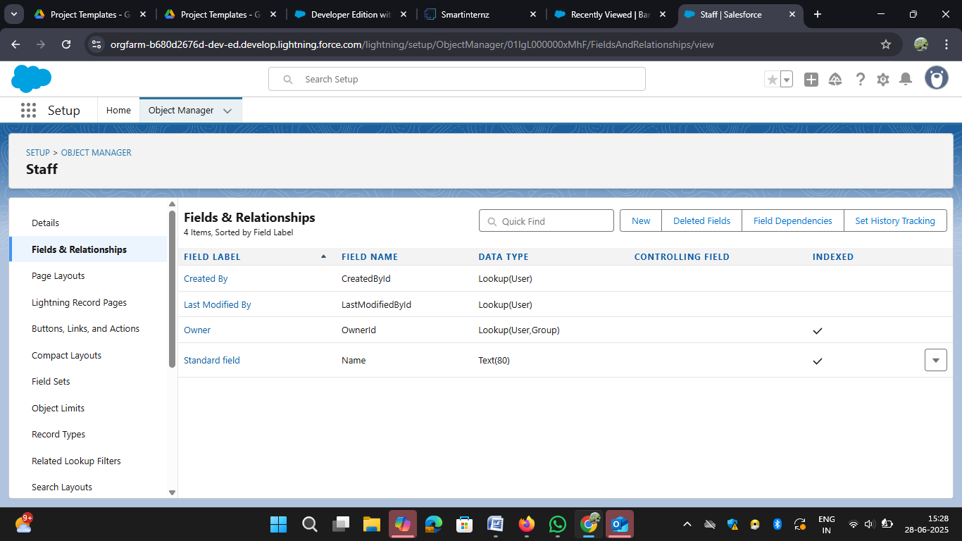

**Billing Object Fields**

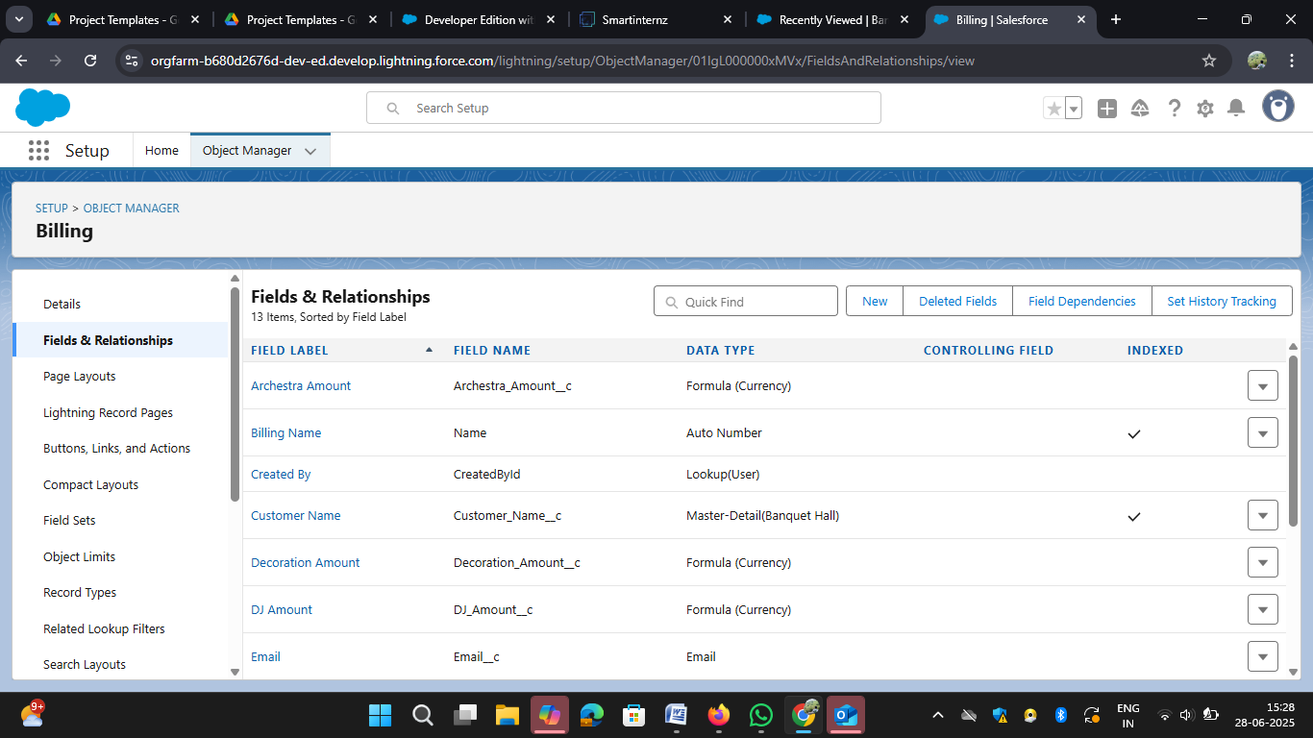

**Milestone 6: Page Layouts**

● Customized page layouts per object.

● Grouped fields logically for usability.

● Enhanced record readability and data entry experience.

**OUTPUT SCREENSHOT**

**Banquet Hall object Page Layouts**

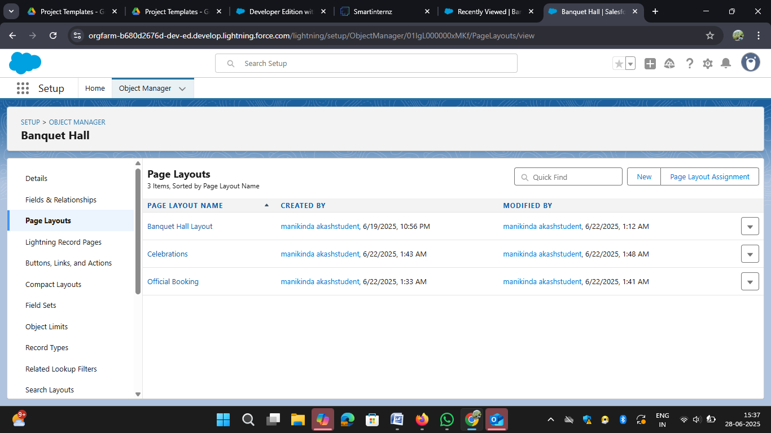

**Staff object Page Layouts**

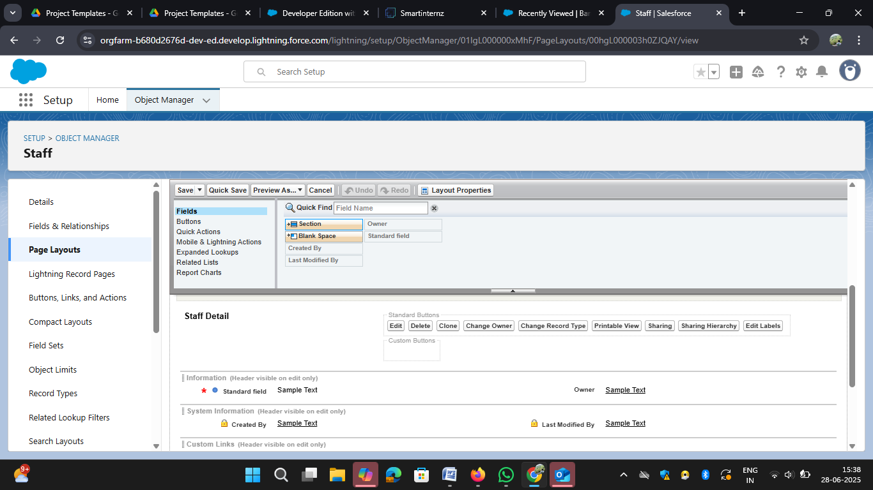

**Billing object Page Layouts**

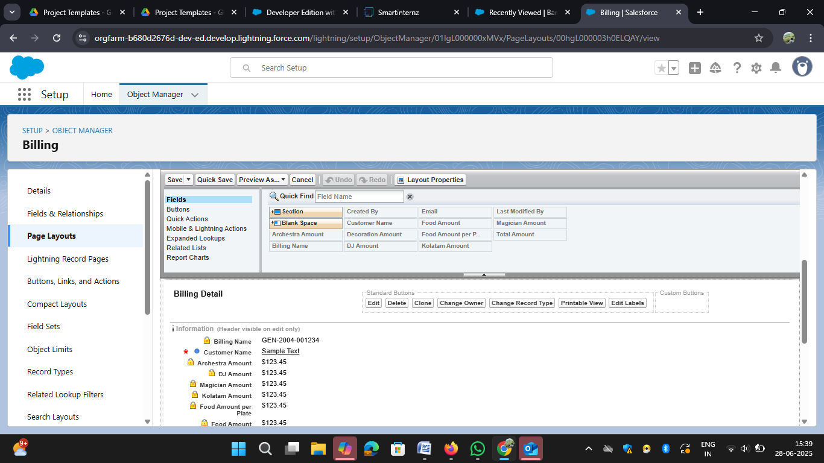

**Milestone 7: Creation Of Record Types**

Type of record is created

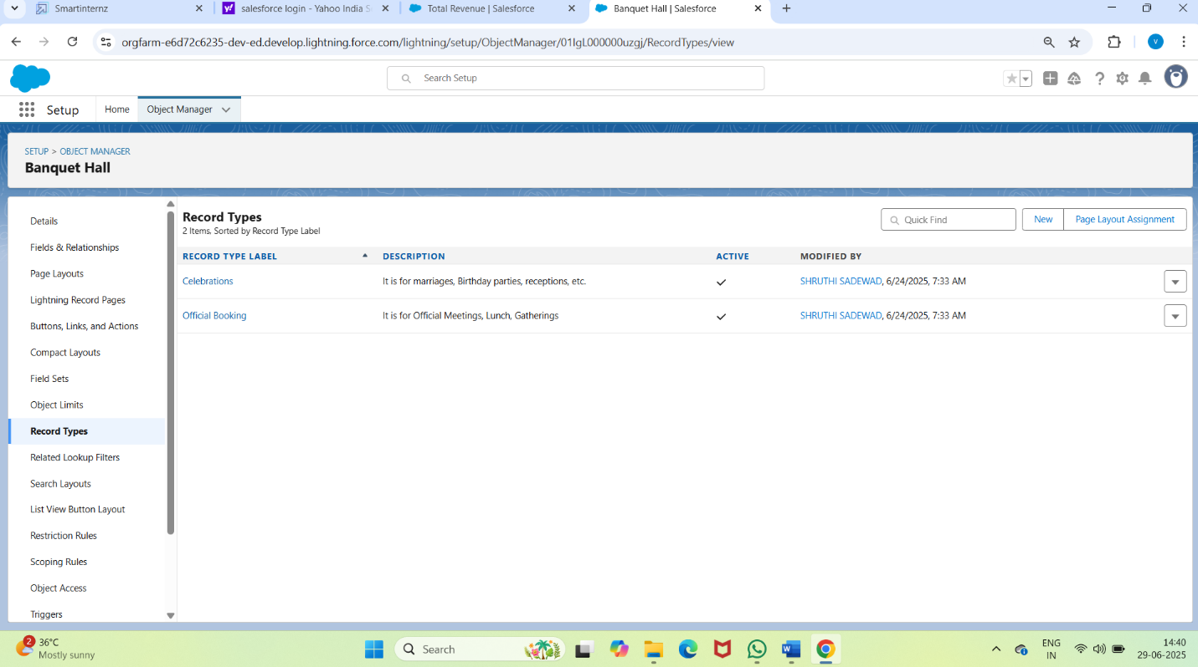

**Milestone 8: Validation Rules**

* Enforced data quality with validations like:
* Booking_Date__c  <=  TODAY(), “Booking Date must be a future Date”.
* Prevented invalid inputs and ensured system reliability.

**OUTPUT SCREENSHOT**

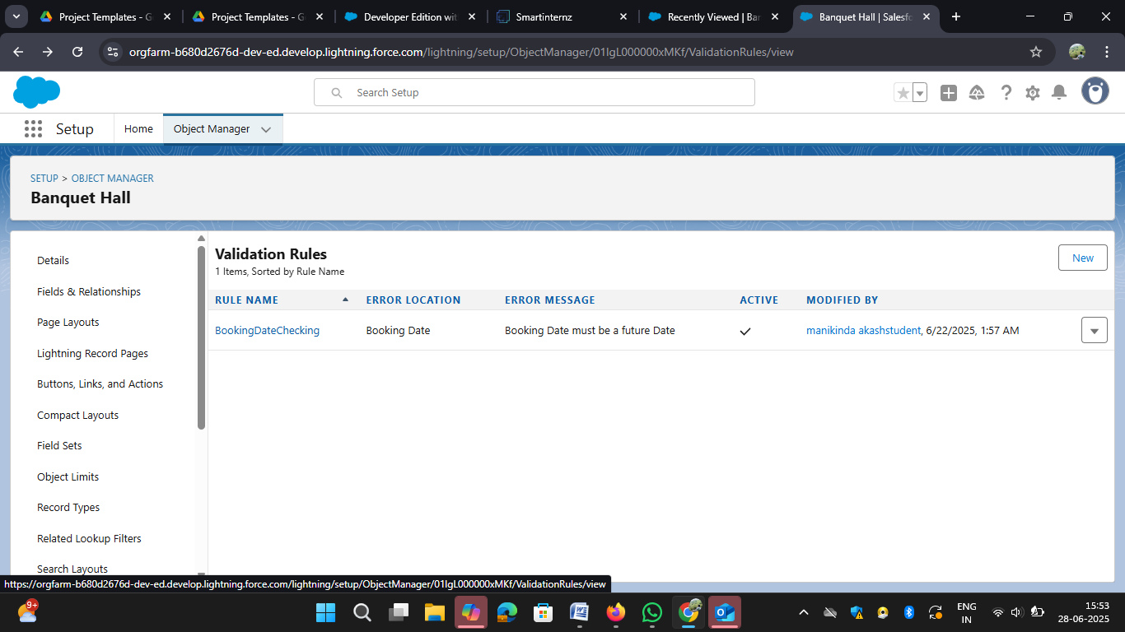

**Milestone 9: Flow Setup**

* Designed a record-triggered flow
* Improved automation and reduced manual input errors

**OUTPUT SCREENSHOT**

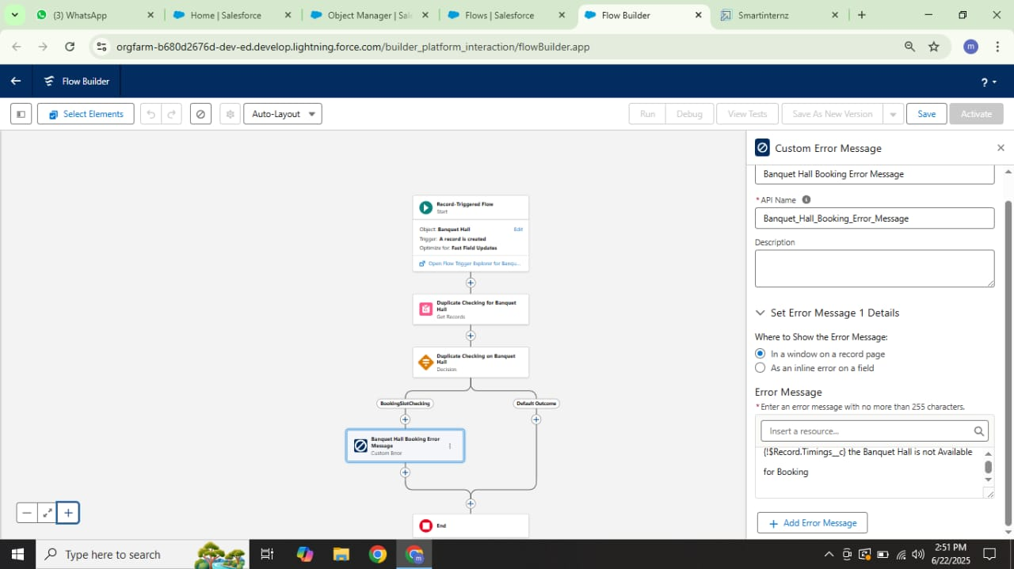

**Milestone 10: Apex Trigger**

* Developed a trigger to validate:

○ Only users with role “Event Coordinator” can be added as Event Coordinator.

○ Only “Staff” can be added as Staff.

● Ensured business logic is enforced at data level

**OUTPUT SCREENSHOT**

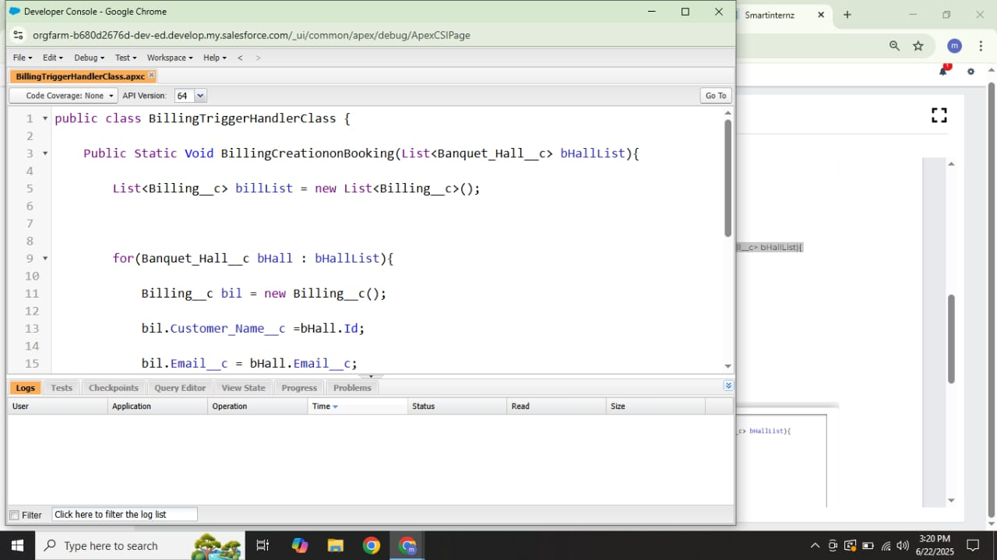

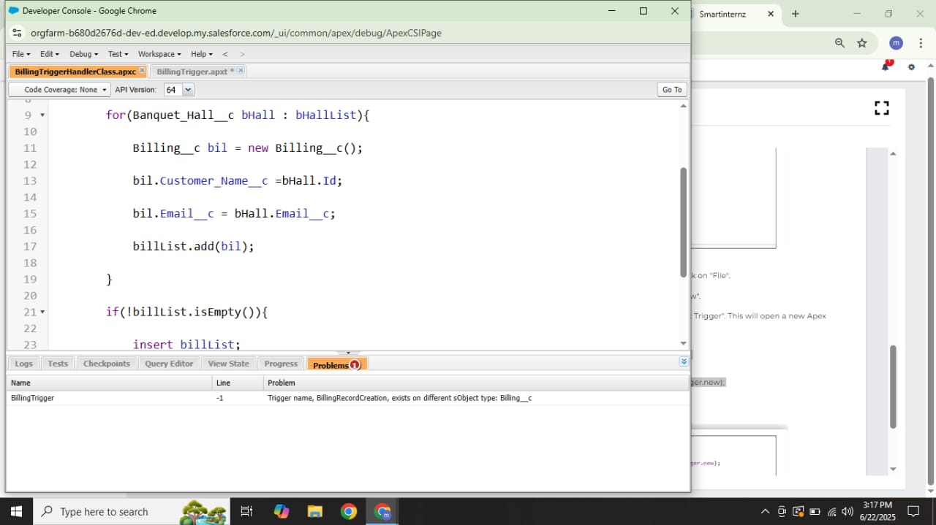

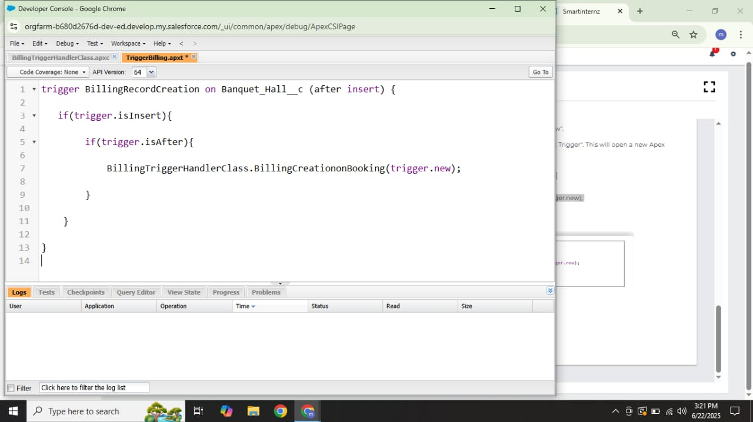**Milestone 11: Reports**

● Created reports for:

* Banquet Halls with Billings Report

● Used grouping, filters, and field summaries.

● Enabled data-driven decision-making.

**OUTPUT SCREENSHOT**

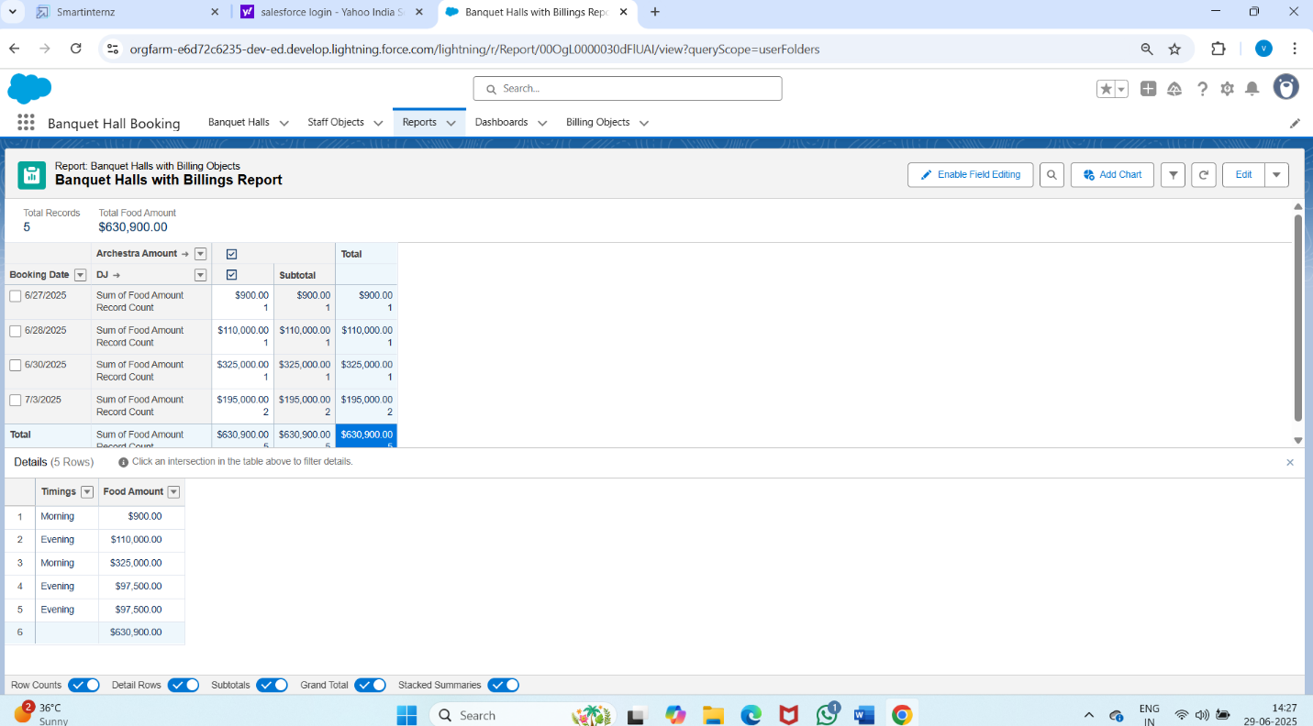

**Milestone 12: Dashboards**

● Designed dashboards showing:

○ Total Revenue and role summary.

● Used pie, and summary widgets for visualization.

**OUTPUT SCREENSHOT**

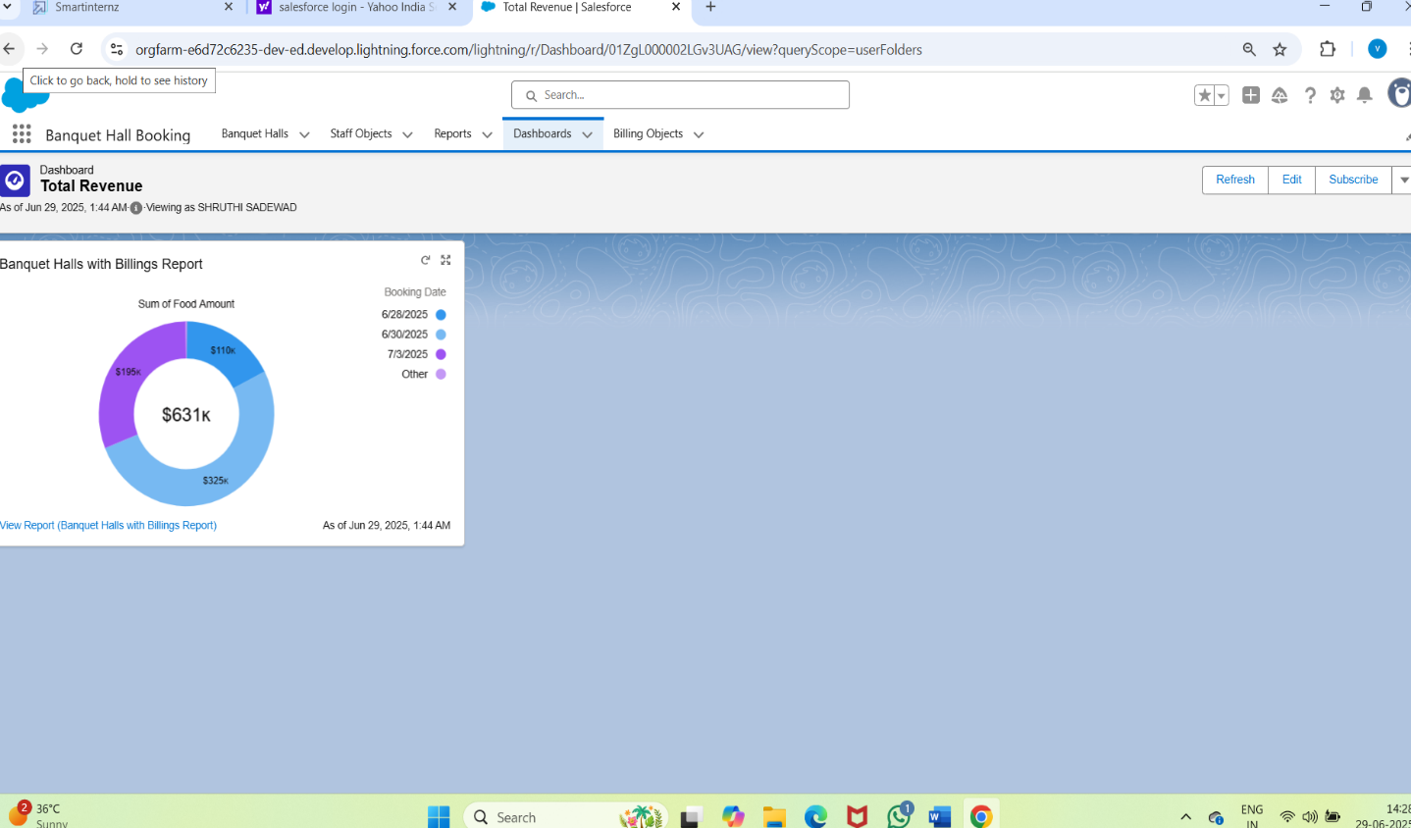

**Milestone 12: Final Review**

● Conducted full system testing.

● Checked all object links, flows, triggers, reports.

● Confirmed the CRM is fully functional and stable.

**Dataset**

The system was tested with the following types of data:(Sample Records and

Input Values Used During Testing)

|  |  |
| --- | --- |
| **Object** | **Samples Fields Used** |
| Venue | Name: Grand Plaza,  Location: Downtown, capacity |
| Customer | Name: Rajesh,  Email: rajesh@gmail.com |
| Event Coordinator | Name: Priya, Role: Event Coordinator,  phone: 8910985504 |
| Vendor Package | Package Name: Premium Catering,  Services included: Catering, Cost:$5000 |
| Booking | Booking ID: B001, Date:2025-06-27,  Number Pf Guests 250,  booking Status: confirmed |
| Payment | Booking ID: B001,Amount:$7500,  Payment Mode: Credit Card |

Note: All test records were created using Salesforce's UI and validated via

flows and formula fields

### 7. FUNCTIONAL AND PERFORMANCE TESTING

**7.1 Performance Testing**

The system was evaluated using realistic booking scenarios and sample data across venues, customers, and service packages. Key validations performed during the testing phase included:

* **Trigger for role validation** (Event Coordinator/Support Staff) to ensure only eligible users were assigned specific event responsibilities
* **Flow for auto-fetching event cost** based on venue, service package, and guest count parameters
* **Field validation for input accuracy**, such as mobile number formats, event dates, and payment fields

|  |  |  |  |
| --- | --- | --- | --- |
| **S.No** | **Parameter** | **Value/Observation** | **Screenshot suggestion** |
| 1. | Model Summary | Salesforce CRM setup for the Banquet Hall Booking project leverages custom objects, relationships, automation flows, and validation triggers to streamline event operations. All configurations are aligned with the defined schema to support data integrity. Test data import succeeds only if object relationships and formats are accurate. |  |
| 2. | Field Validations | Tested rules such as:   * Age must be above 21 for staff and customer eligibility * Phone number must be exactly 10 digits to ensure contact accuracy * Mandatory fields (e.g., event date, venue, customer name) cannot be left empty   The system successfully blocks incorrect or incomplete entries to uphold data integrity and operational accuracy. |  |
| 3. | Automation Accuracy(Flow +Trigger) | **Flow**: Auto-fetch event cost based on venue, vendor package, and duration  **Trigger**: Validates assigned role is either “Event Coordinator” or “Support Staff”  **Test Result**: All logic executed successfully in trial runs |  |
| 4. | Reports Testing | **Event Summary Report** displays correct grouping by **venue** and **event date**  **Total cost and guest counts** are accurately calculated using **formula fields**  **Report export and download functions** tested and confirmed working as expected |  |
| 5. | Dashboard Verification | Dashboards built using correct source reports from bookings, venues, and payments  Visuals reflect live event data like booking counts, total revenue  Tested filter logic and component refresh for real-time accuracy |  |
| 6. | Data Accuracy (Manual +Automated) | Manual test records were entered to validate input rules and automation flows  Flow logic was verified for various combinations of venue, vendor packages, and guest count  Output values matched expected results across all test scenarios, confirming accurate system behavior |  |

**Summary**

All Salesforce components were thoroughly tested for:

● Validation rule enforcement

● Flow and trigger logic correctness

● Dashboard accuracy

● Report reliability

● Data relationships integrity

**8. RESULTS**

**Output Screenshots**

Key functional screenshots include:

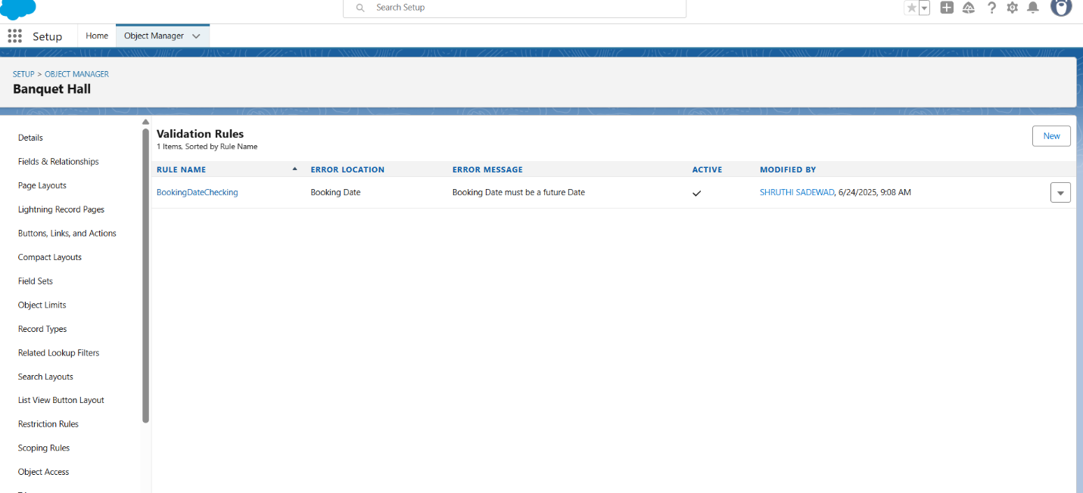

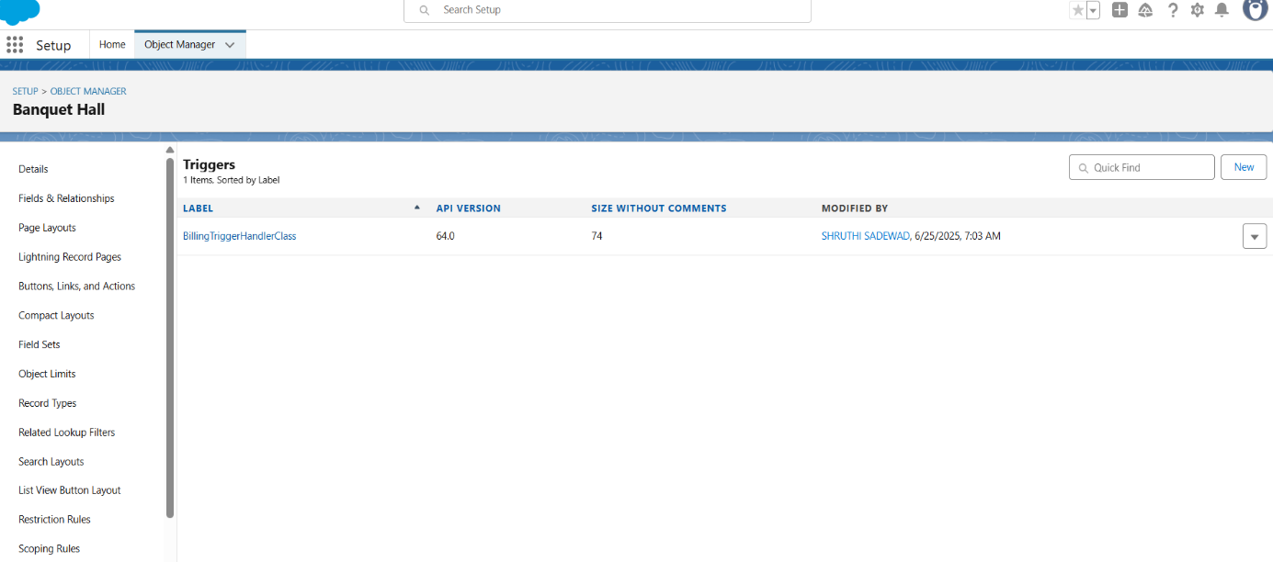

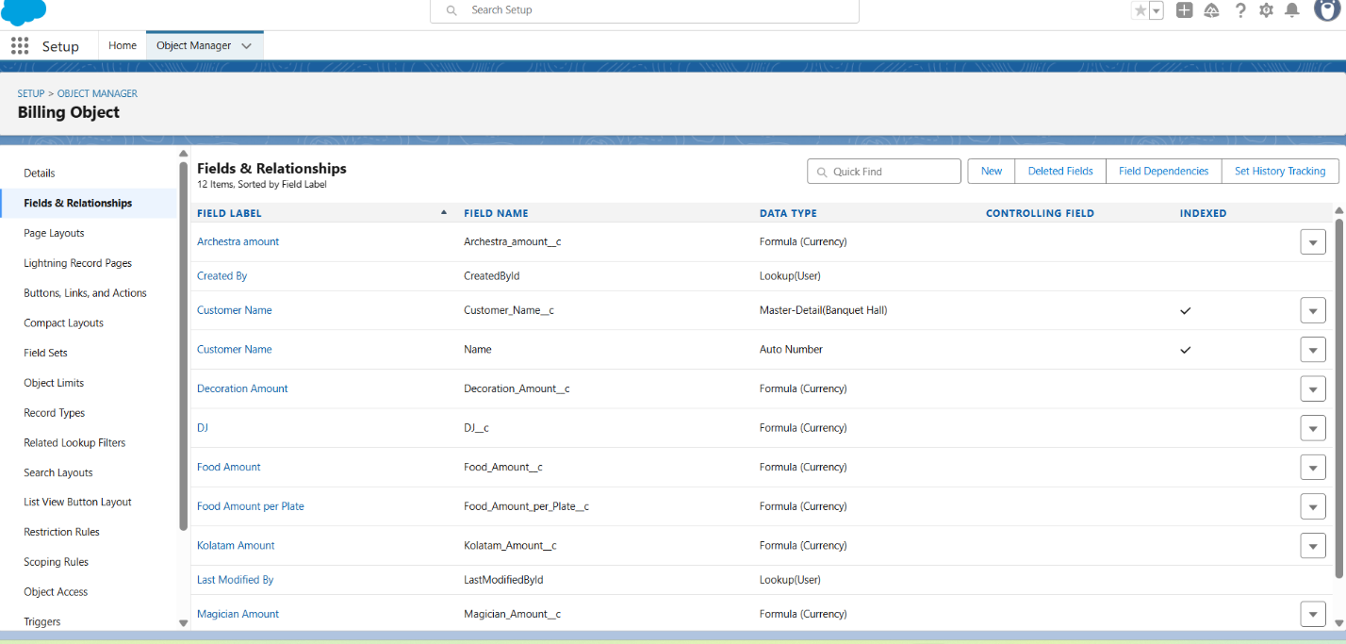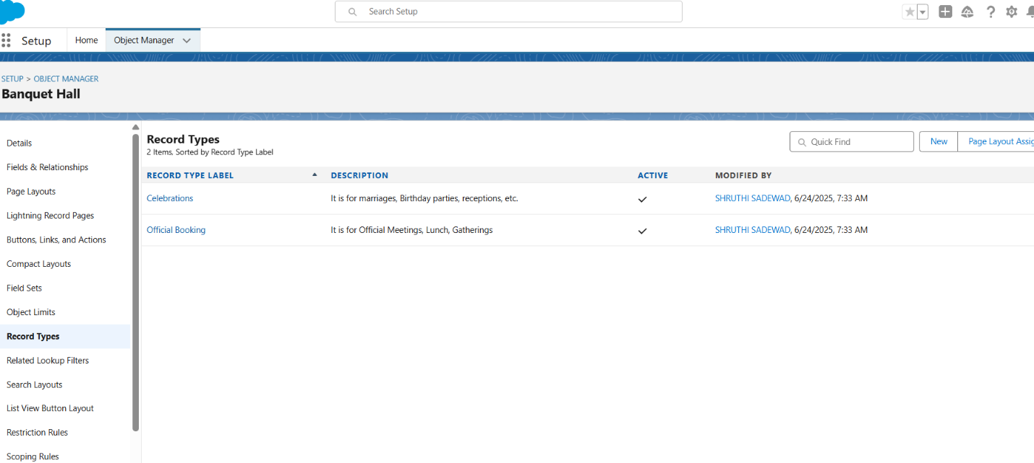

**9. ADVANTAGES & DISADVANTAGES**

**Advantages**

● Real-time data validation and automation

● Modular structure allows easy customization

● Centralized and streamlined process for booking, event cost, and staff coordination

● Visual reports and dashboards for decision-making

**Disadvantages**

● Requires knowledge of Salesforce for advanced use

● Limited functionality in offline mode due to cloud dependency

● Dependent on correctly established object relationships

**10. CONCLUSION**

The project successfully delivered a customized Salesforce CRM application tailored to banquet hall booking operations. It streamlined event management workflows, addressed key operational inefficiencies, and enhanced user coordination across venues, vendors, and customers. The initiative also offered valuable learning opportunities for the team in both declarative and programmatic Salesforce development, reinforcing best practices in CRM design, automation, and scalability.

**11. FUTURE SCOPE**

The Banquet Hall Booking CRM can be further enhanced with the following capabilities:

* **Third-party payment and service integration** for seamless vendor payments and guest-facing ticketing
* **Automated alerts and communication workflows** (e.g., SMS/email reminders for bookings and payment confirmations)
* **Mobile-first interface via Salesforce Experience Cloud** to allow customers and vendors to access bookings on the go
* **AI-powered forecasting using Salesforce Einstein** to predict peak booking periods, service demand, and revenue patterns